Weekend 05-01-2025

1. Inventory Update System

\* Input: An array of integers representing inventory levels and an array of changes in stock.

\* Process: Pass the arrays to a function by reference to update inventory levels.

\* Output: Print the updated inventory levels and flag items below the restocking threshold.

\* Concepts: Arrays, functions, pass by reference, decision-making (if-else).

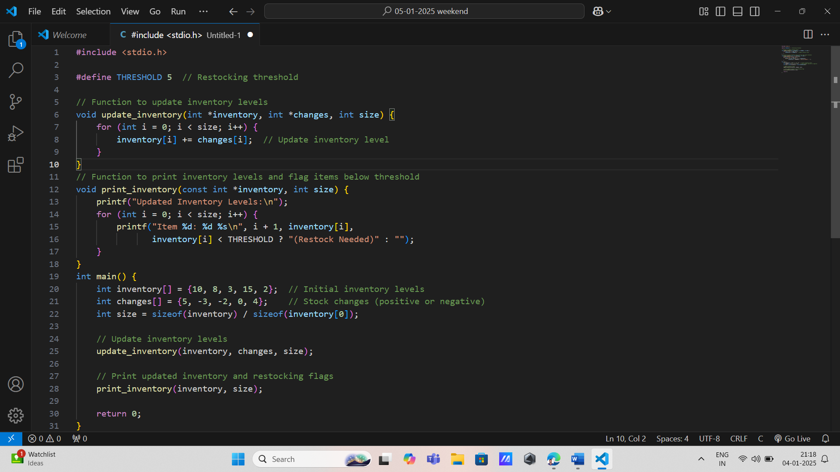

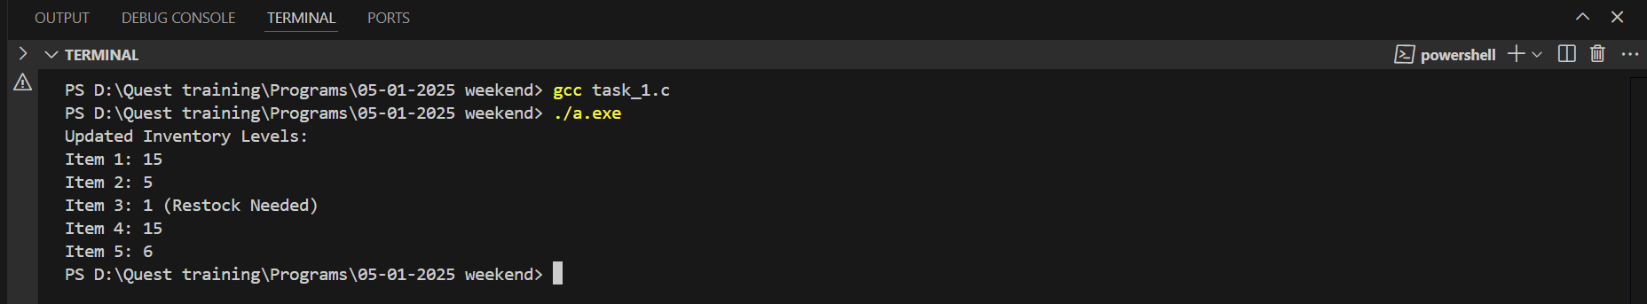

2. Product Price Adjustment

\* Input: An array of demand levels (constant) and an array of product prices.

\* Process: Use a function to calculate new prices based on demand levels. The function should return a pointer to an array of adjusted prices.

\* Output: Display the original and adjusted prices.

\* Concepts: Passing constant data, functions, pointers, arrays.

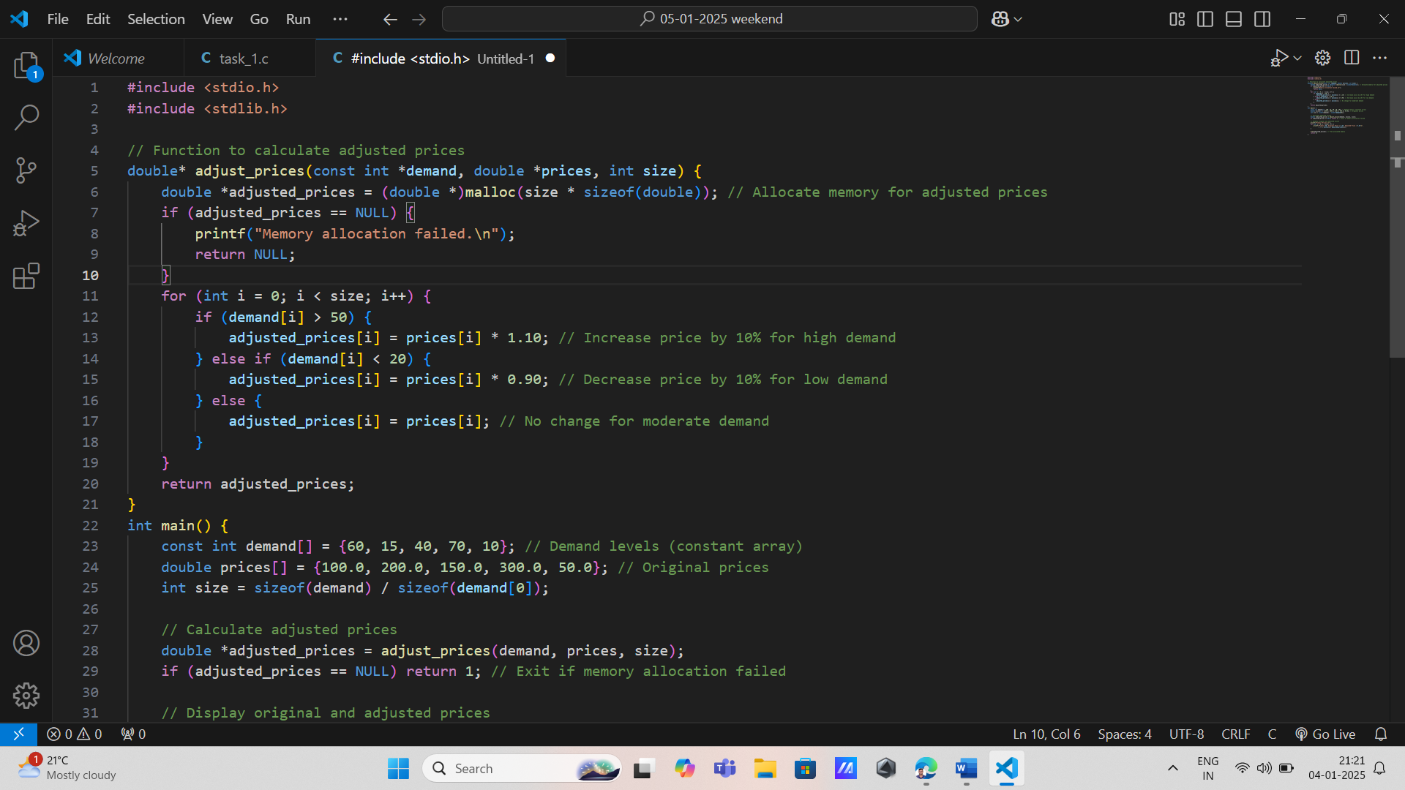

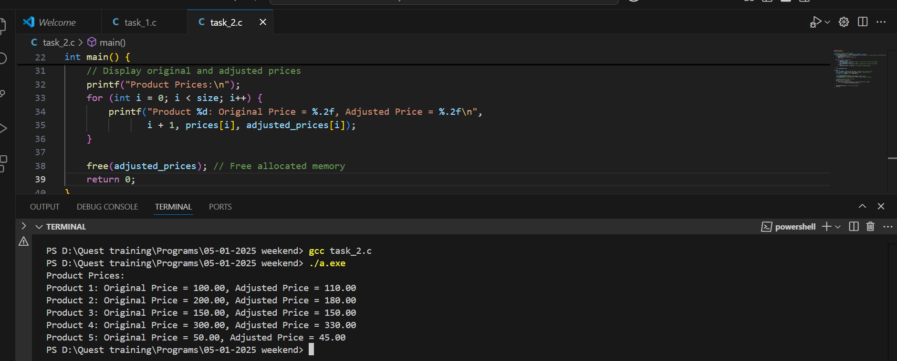

3. \* Daily Sales Tracker

\* Input: Array of daily sales amounts.

\* Process: Use do-while to validate sales data input. Use a function to calculate total sales using pointers.

\* Output: Display total sales for the day.

\* Concepts: Loops, arrays, pointers, functions.

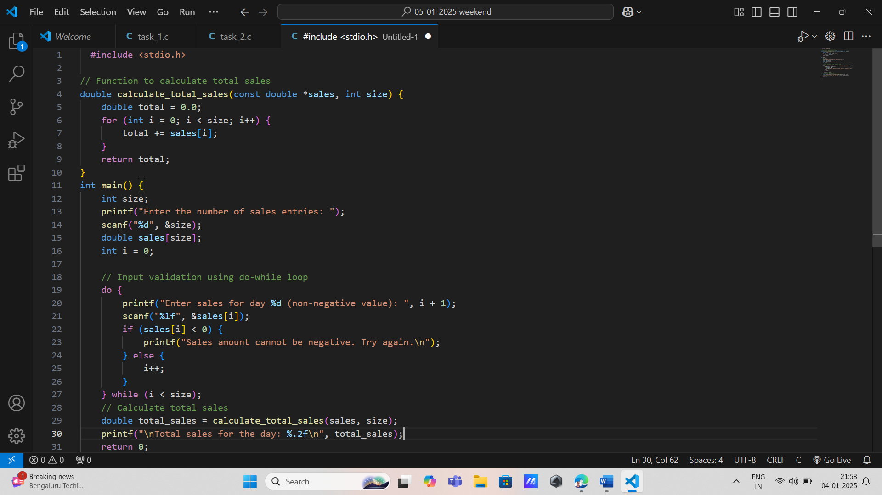

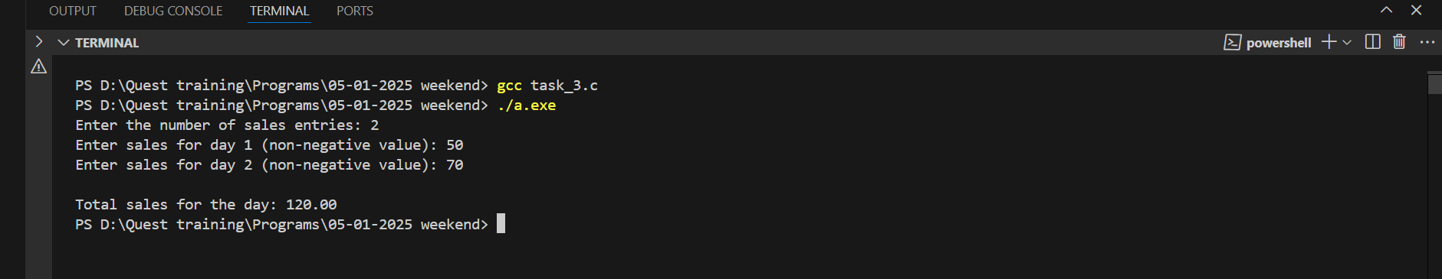

3. Discount Decision System

\* Input: Array of sales volumes.

\* Process: Pass the sales volume array by reference to a function. Use a switch statement to assign discount rates.

\* Output: Print discount rates for each product.

\* Concepts: Decision-making (switch), arrays, pass by reference, functions.

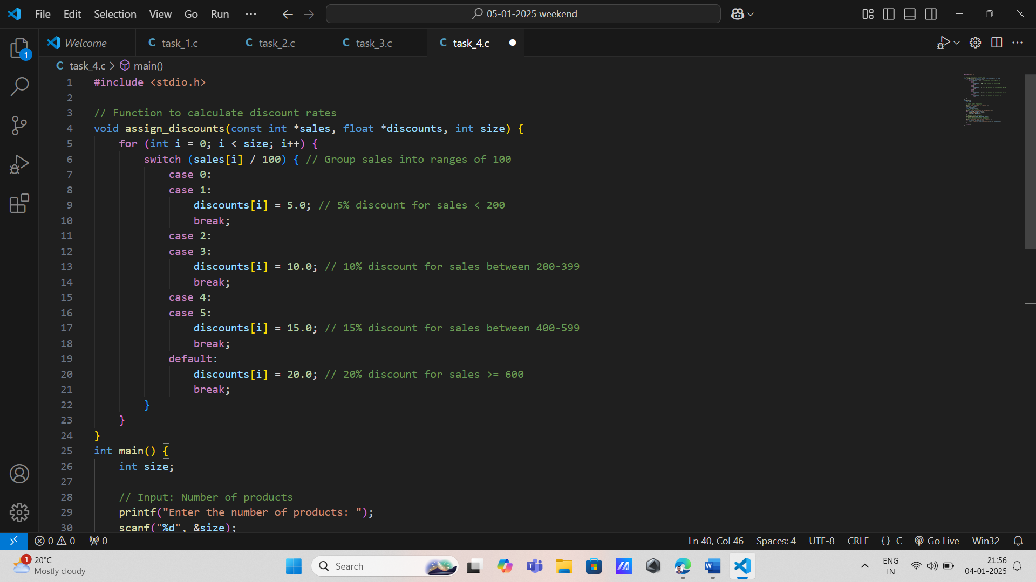

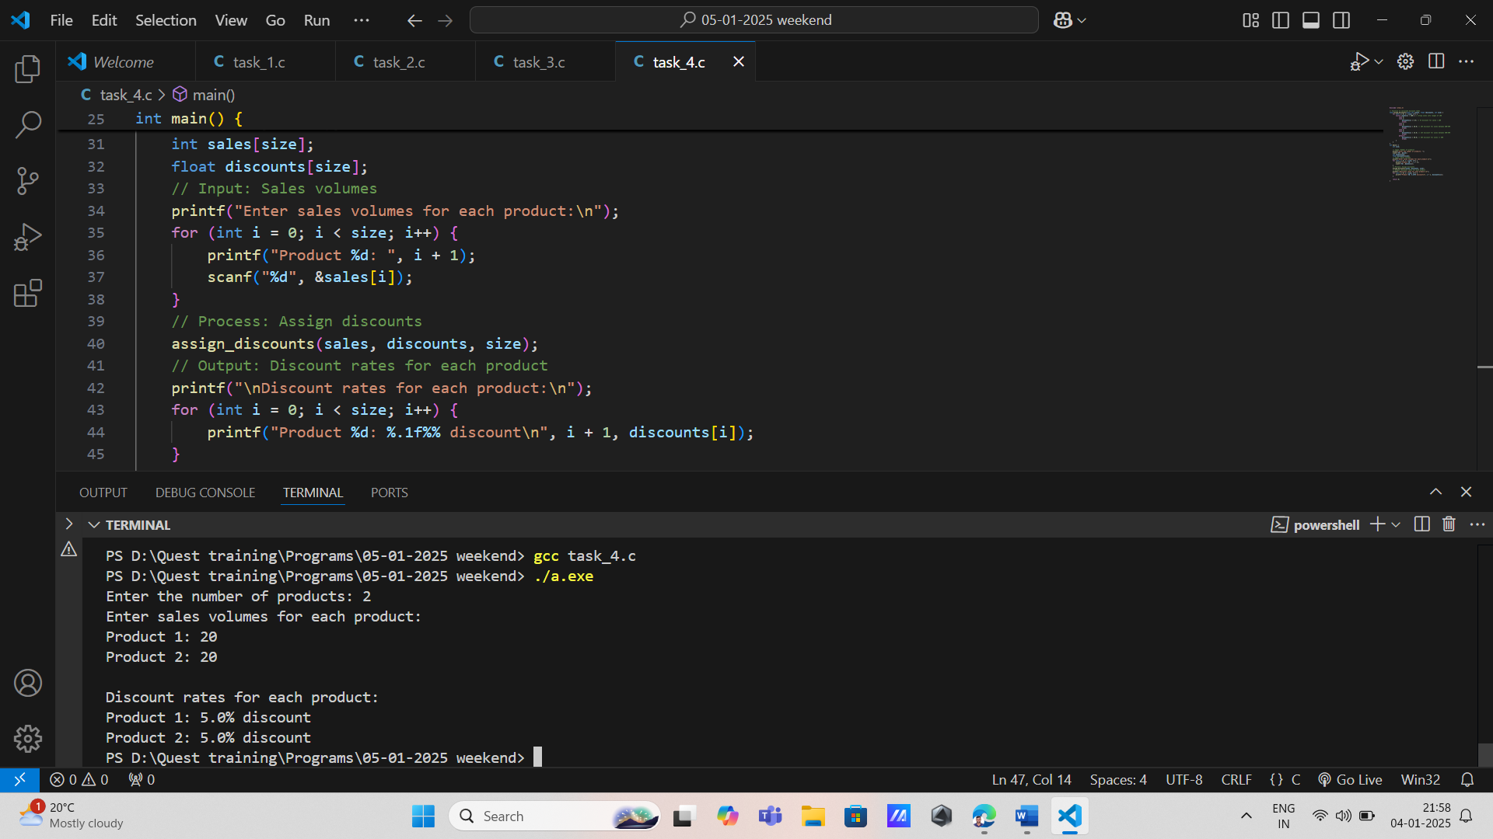

4. Transaction Anomaly Detector

\* Input: Array of transaction amounts.

\* Process: Use pointers to traverse the array. Classify transactions as "Normal" or "Suspicious" based on thresholds using if-else.

\* Output: Print classification for each transaction

\* Concepts: Arrays, pointers, loops, decision-making.

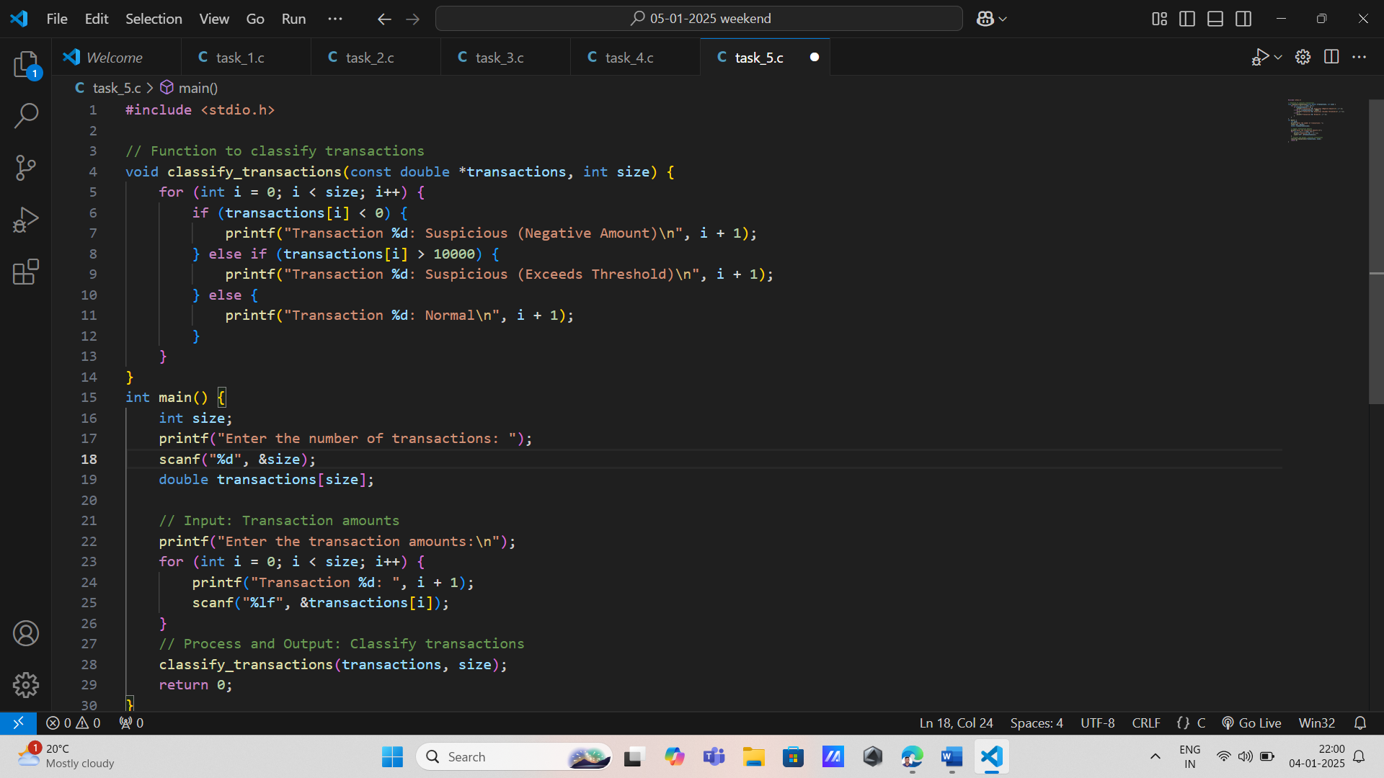

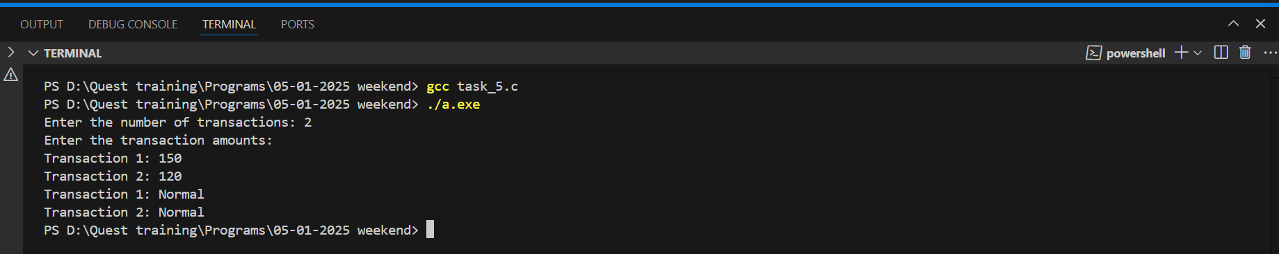

6. Account Balance Operations

\* Input: Array of account balances.

\* Process: Pass the balances array to a function that calculates interest. Return a pointer to the updated balances array.

\* Output: Display updated balances

\* Concepts: Functions, arrays, pointers, loops.

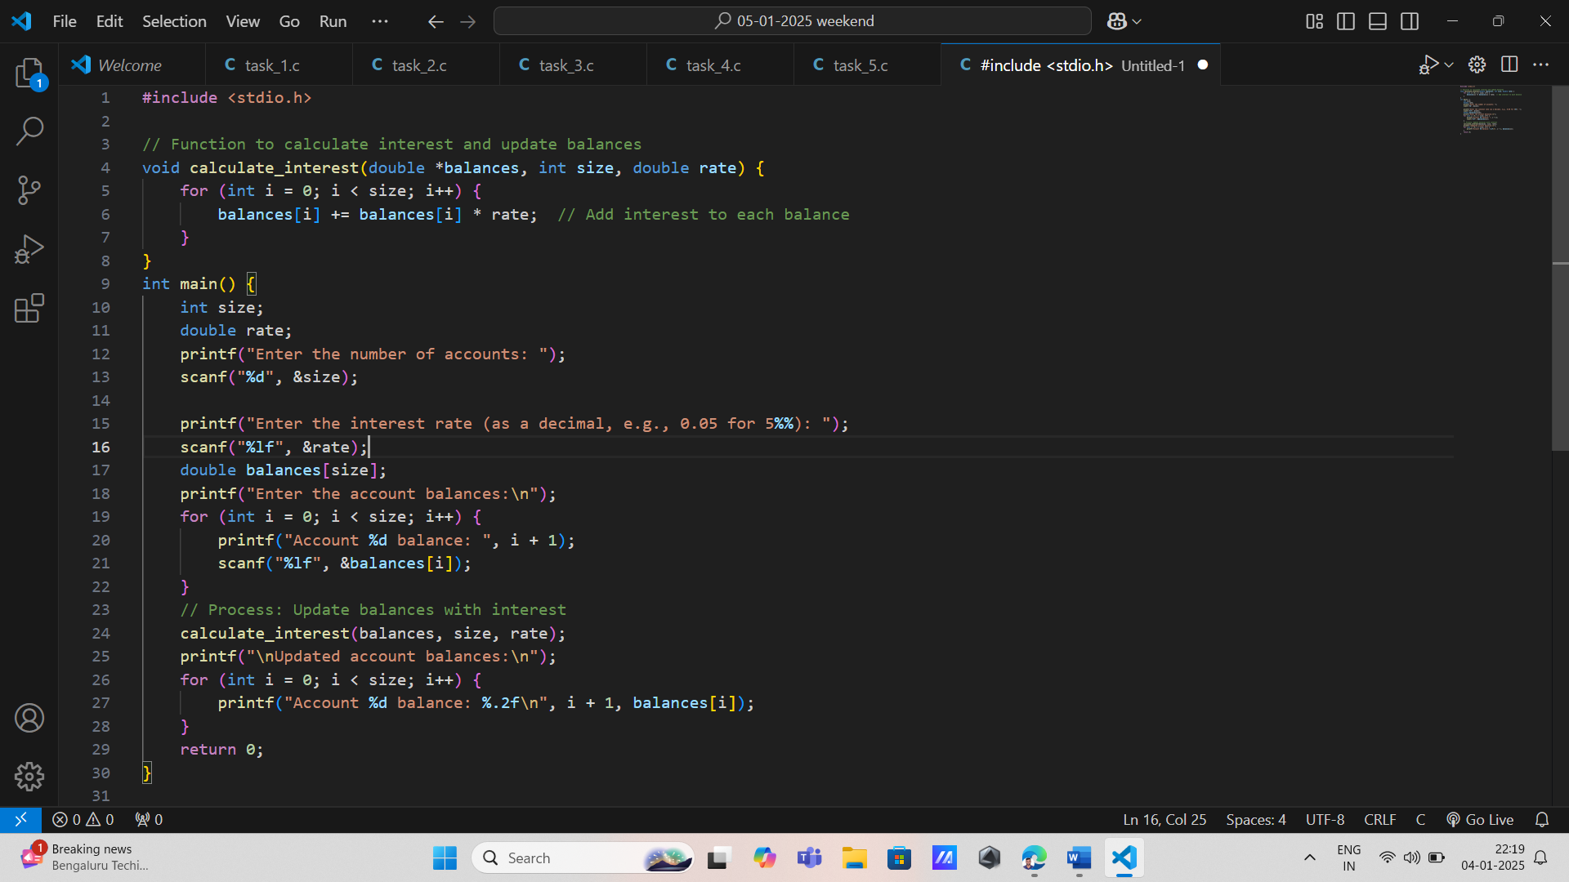

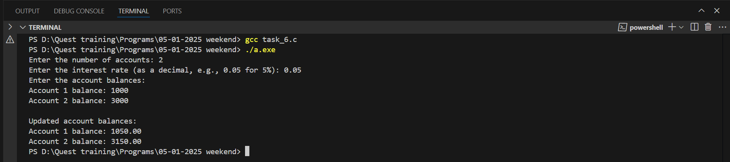

7. Bank Statement Generator

\* Input: Array of transaction types (e.g., 1 for Deposit, 2 for Withdrawal) and amounts.

\* Process: Use a switch statement to classify transactions. Pass the array as a constant parameter to a function.

\* Output: Summarize total deposits and withdrawals.

\* Concepts: Decision-making, passing constant data, arrays, functions.

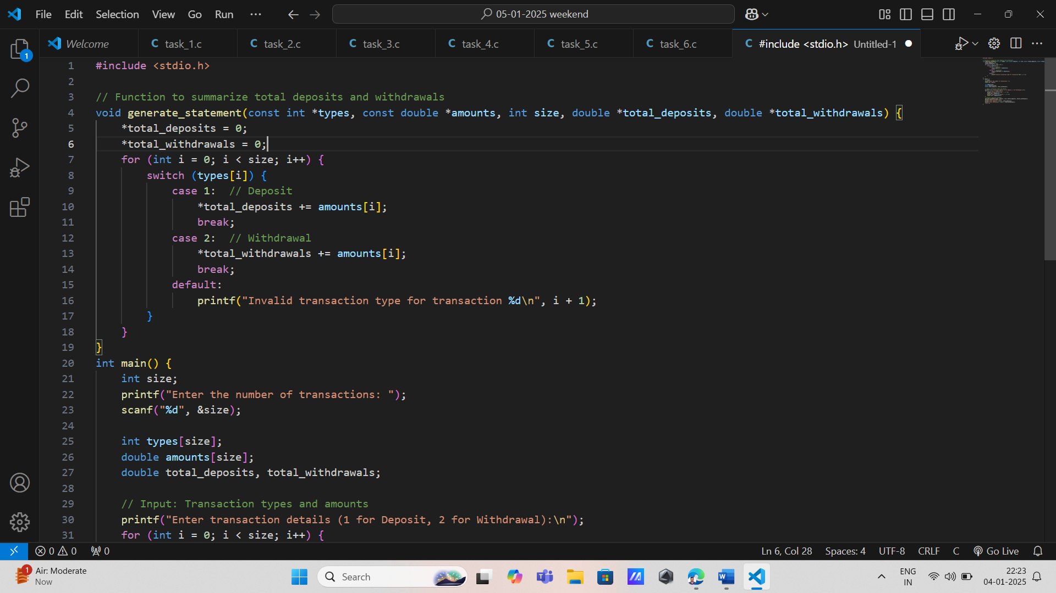

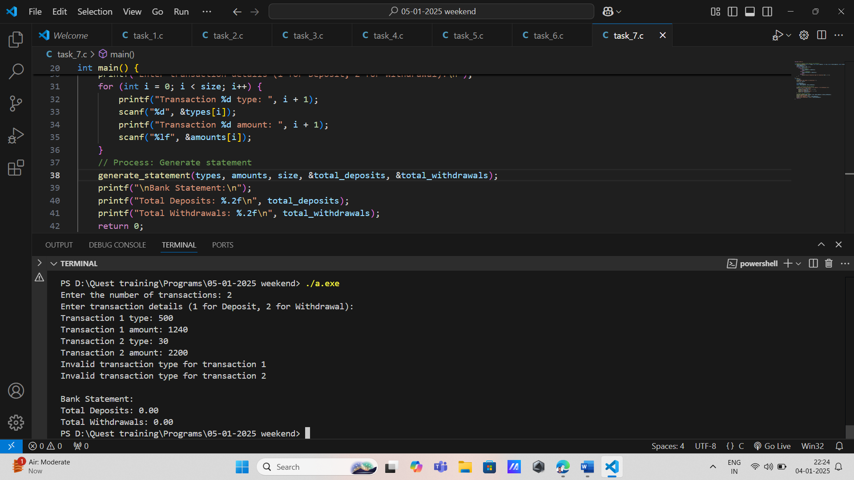

8. Loan Eligibility Check

\* Input: Array of customer credit scores.

\* Process: Use if-else to check eligibility criteria. Use pointers to update eligibility status.

\* Output: Print customer eligibility statuses.

\* Concepts: Decision-making, arrays, pointers, functions.

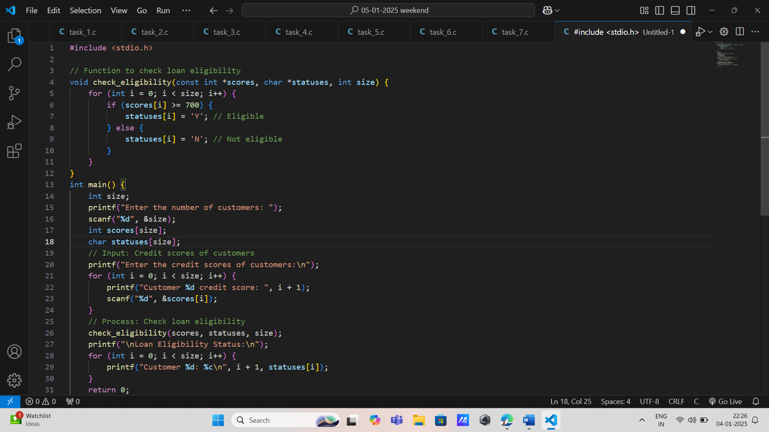

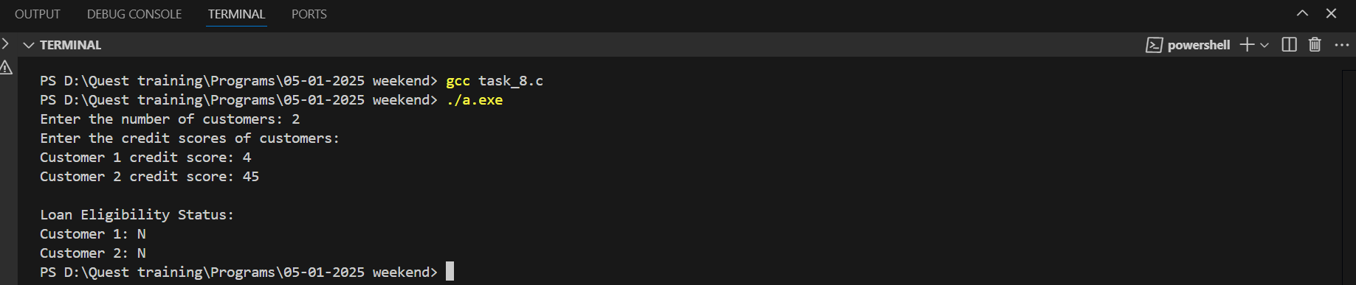

9. \*Order Total Calculator

\* Input: Array of item prices.

\* Process: Pass the array to a function. Use pointers to calculate the total cost.

\* Output: Display the total order value.

\* Concepts: Arrays, pointers, functions, loops.

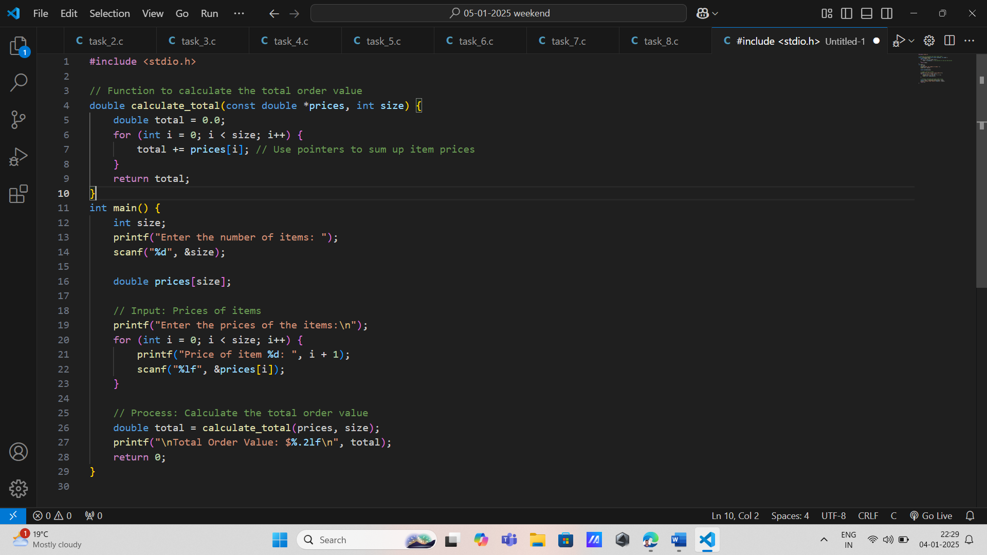

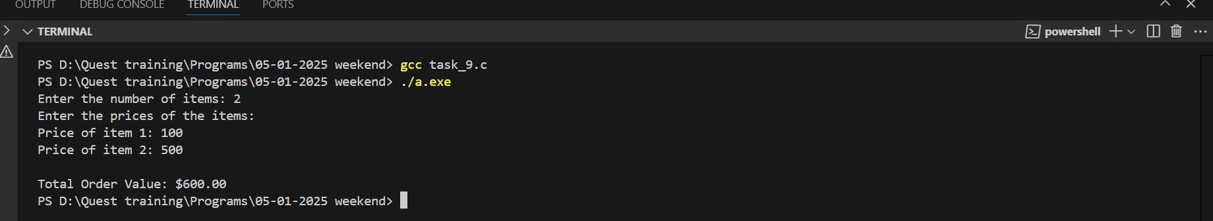

10. Stock Replenishment Alert

\* Input: Array of inventory levels.

\* Process: Use a function to flag products below a threshold. Return a pointer to flagged indices.

\* Output: Display flagged product indices.

\* Concepts: Arrays, functions returning pointers, loops.

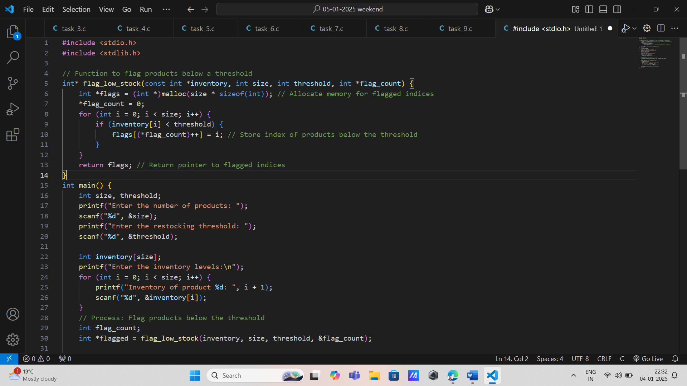

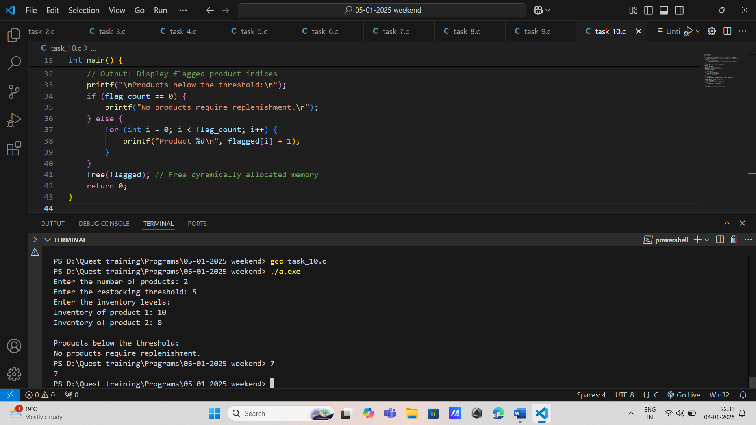

11. \* Customer Reward Points

\* Input: Array of customer purchase amounts.

\* Process: Pass the purchase array by reference to a function that calculates reward points using if-else.

\* Output: Display reward points for each customer.

\* Concepts: Arrays, functions, pass by reference, decision-making.

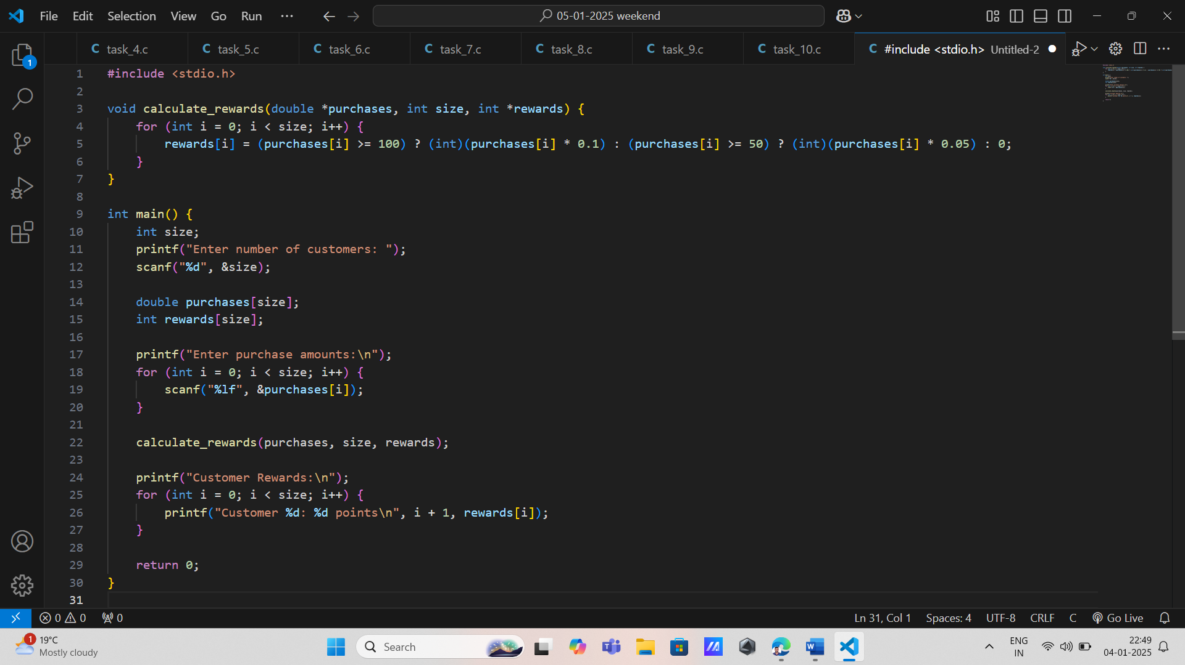

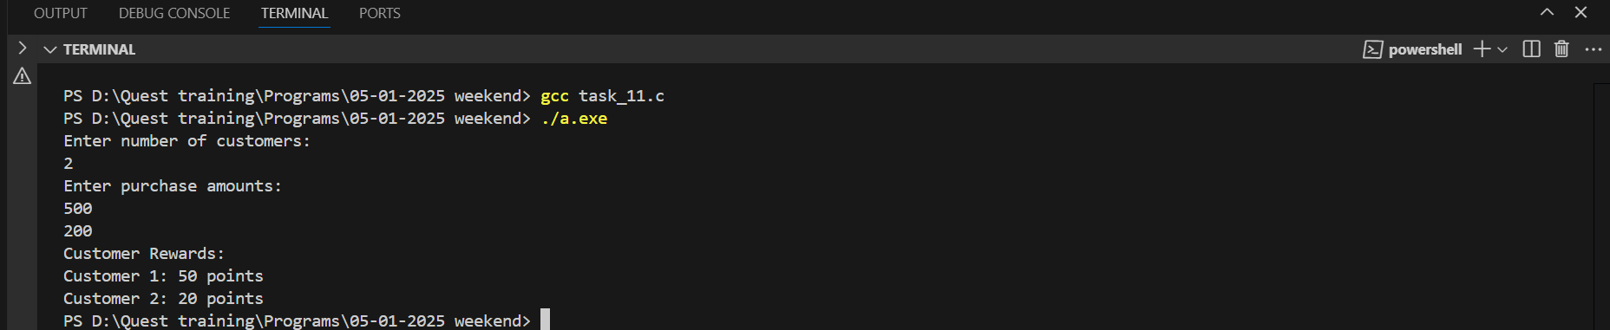

12. Shipping Cost Estimator

\* Input: Array of order weights and shipping zones.

\* Process: Use a switch statement to calculate shipping costs based on zones. Pass the weight array as a constant parameter.

\* Output: Print the shipping cost for each order.

\* Concepts: Decision-making, passing constant data, arrays, functions.

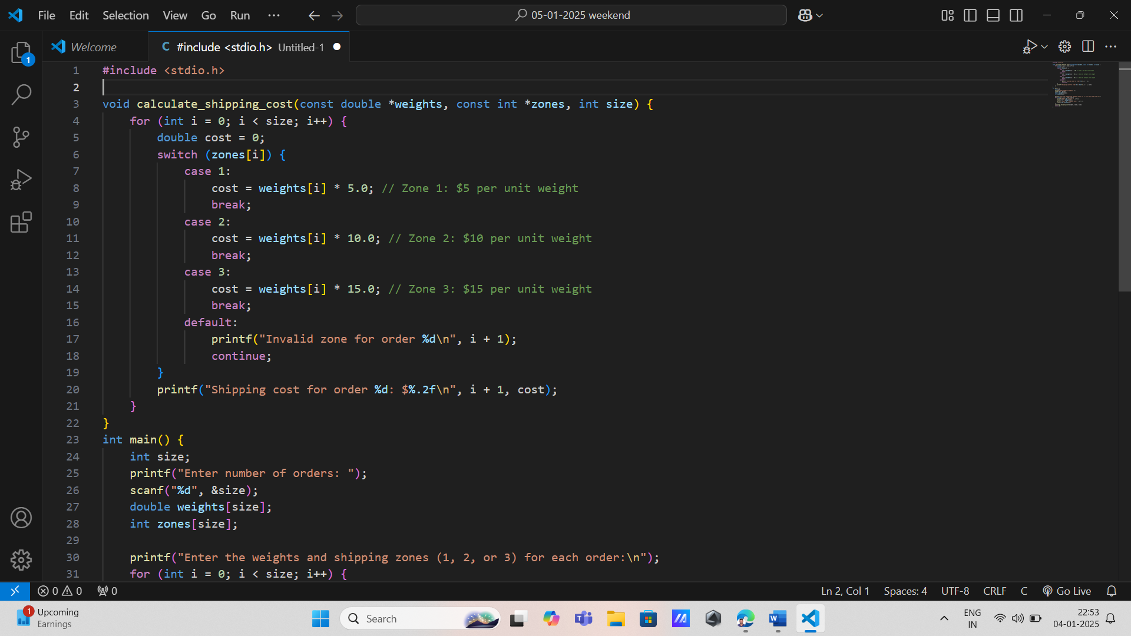

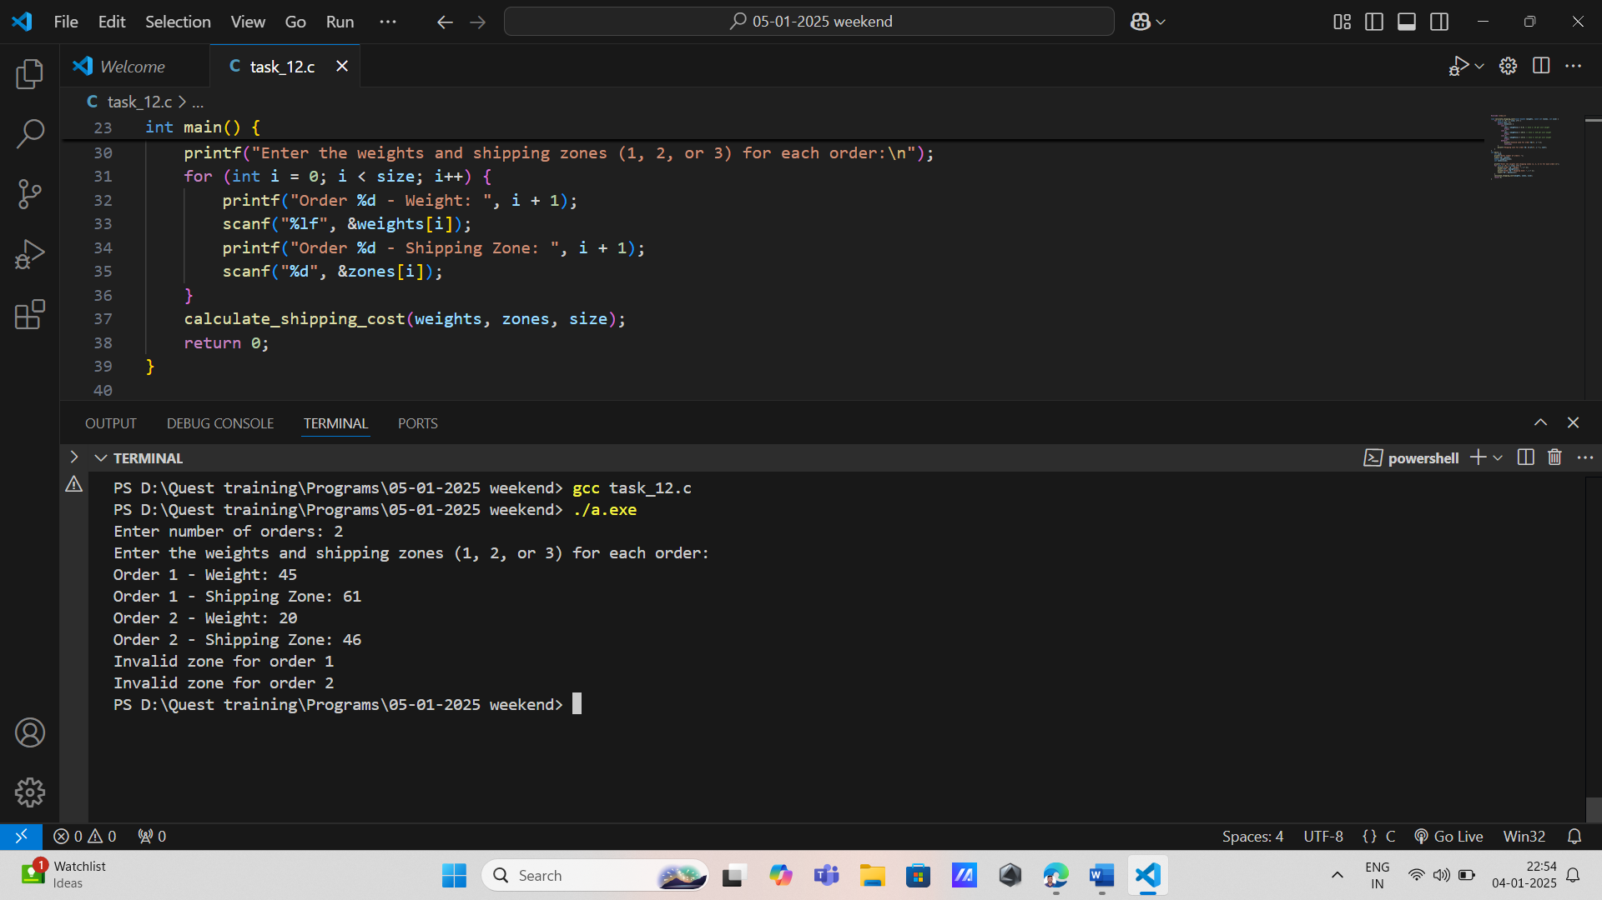

13. Missile Trajectory Analysis

\* Input: Array of trajectory data points.

\* Process: Use functions to find maximum and minimum altitudes. Use pointers to access data.

\* Output: Display maximum and minimum altitudes.

\* Concepts: Arrays, pointers, functions.

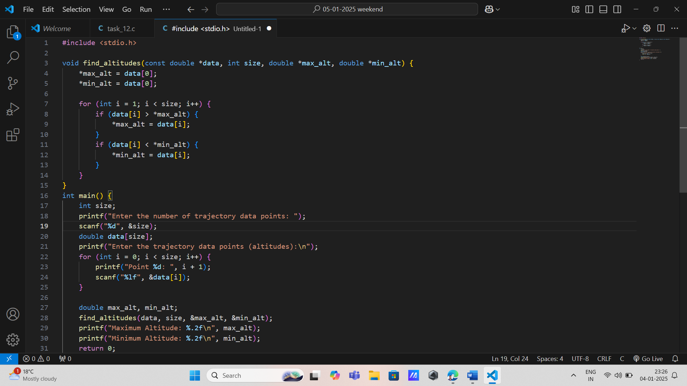

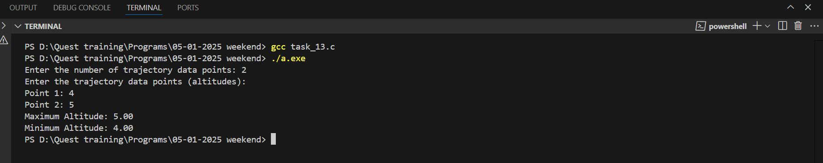

14. Target Identification System

\* Input: Array of radar signal intensities.

\* Process: Classify signals into categories using a switch statement. Return a pointer to the array of classifications.

\* Output: Display classified signal types.

\* Concepts: Decision-making, functions returning pointers, arrays.

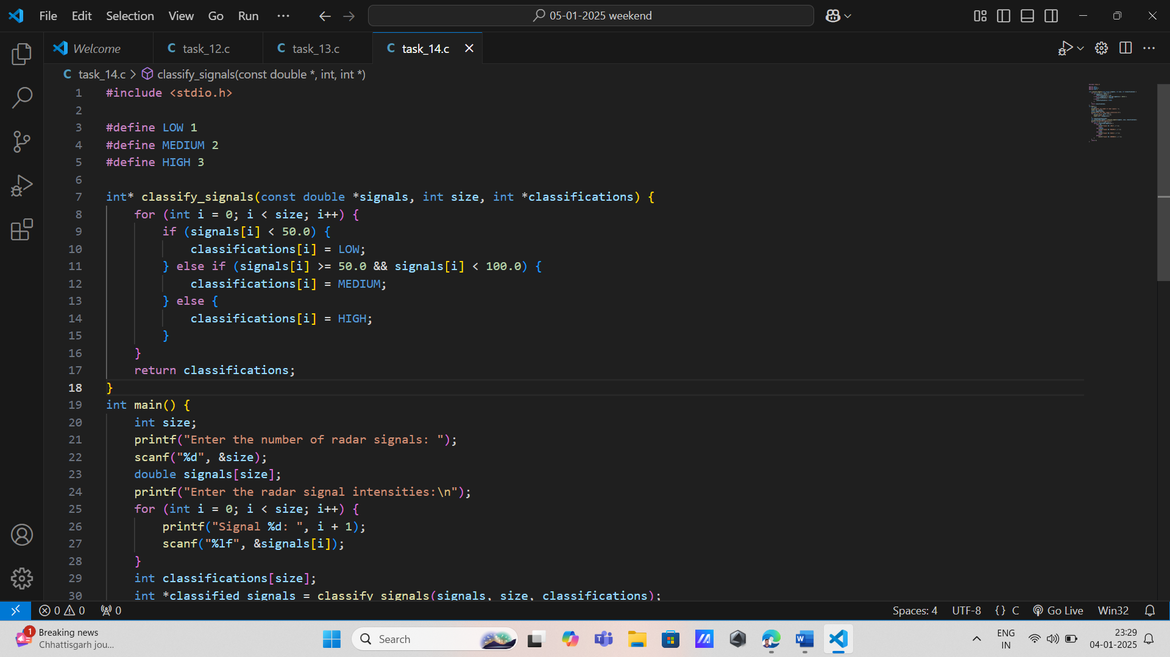

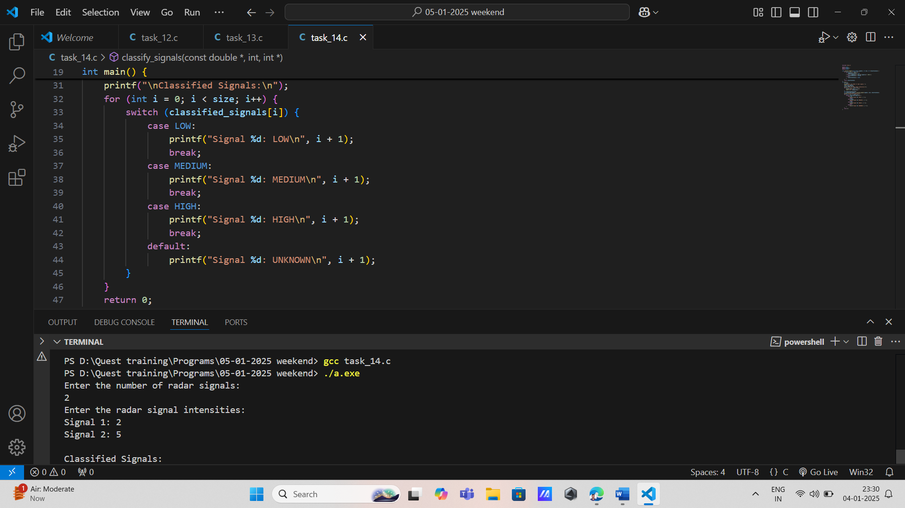

15. Threat Level Assessment

\* Input: Array of sensor readings.

\* Process: Pass the array by reference to a function that uses if-else to categorize threats.

\* Output: Display categorized threat levels.

\* Concepts: Arrays, functions, pass by reference, decision-making.

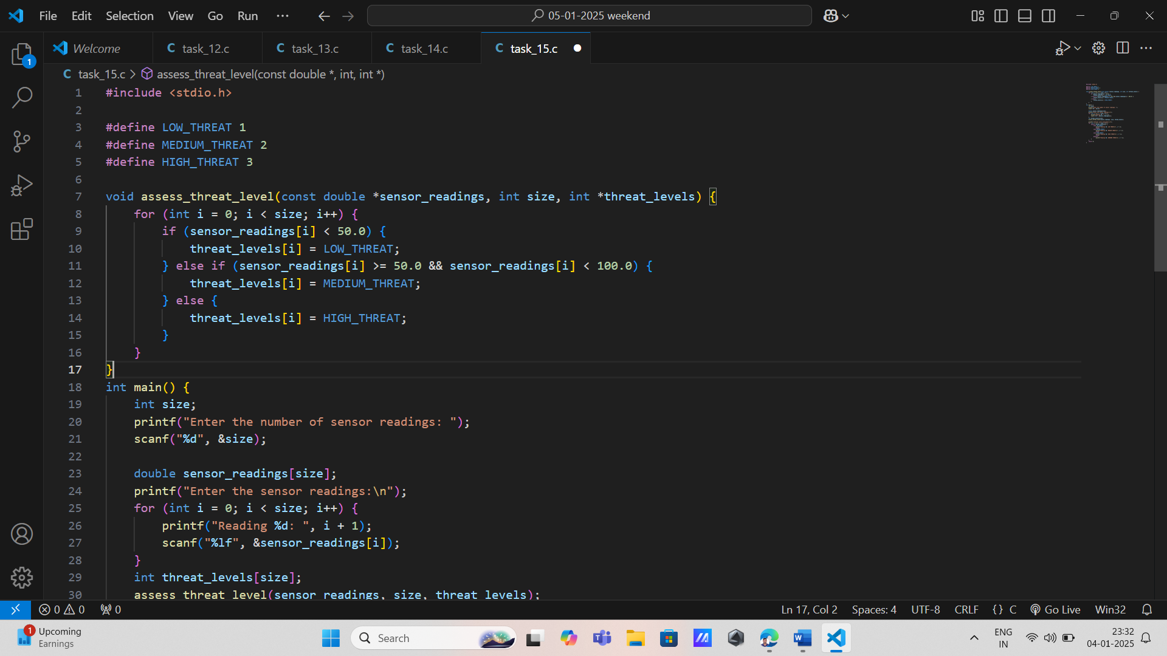

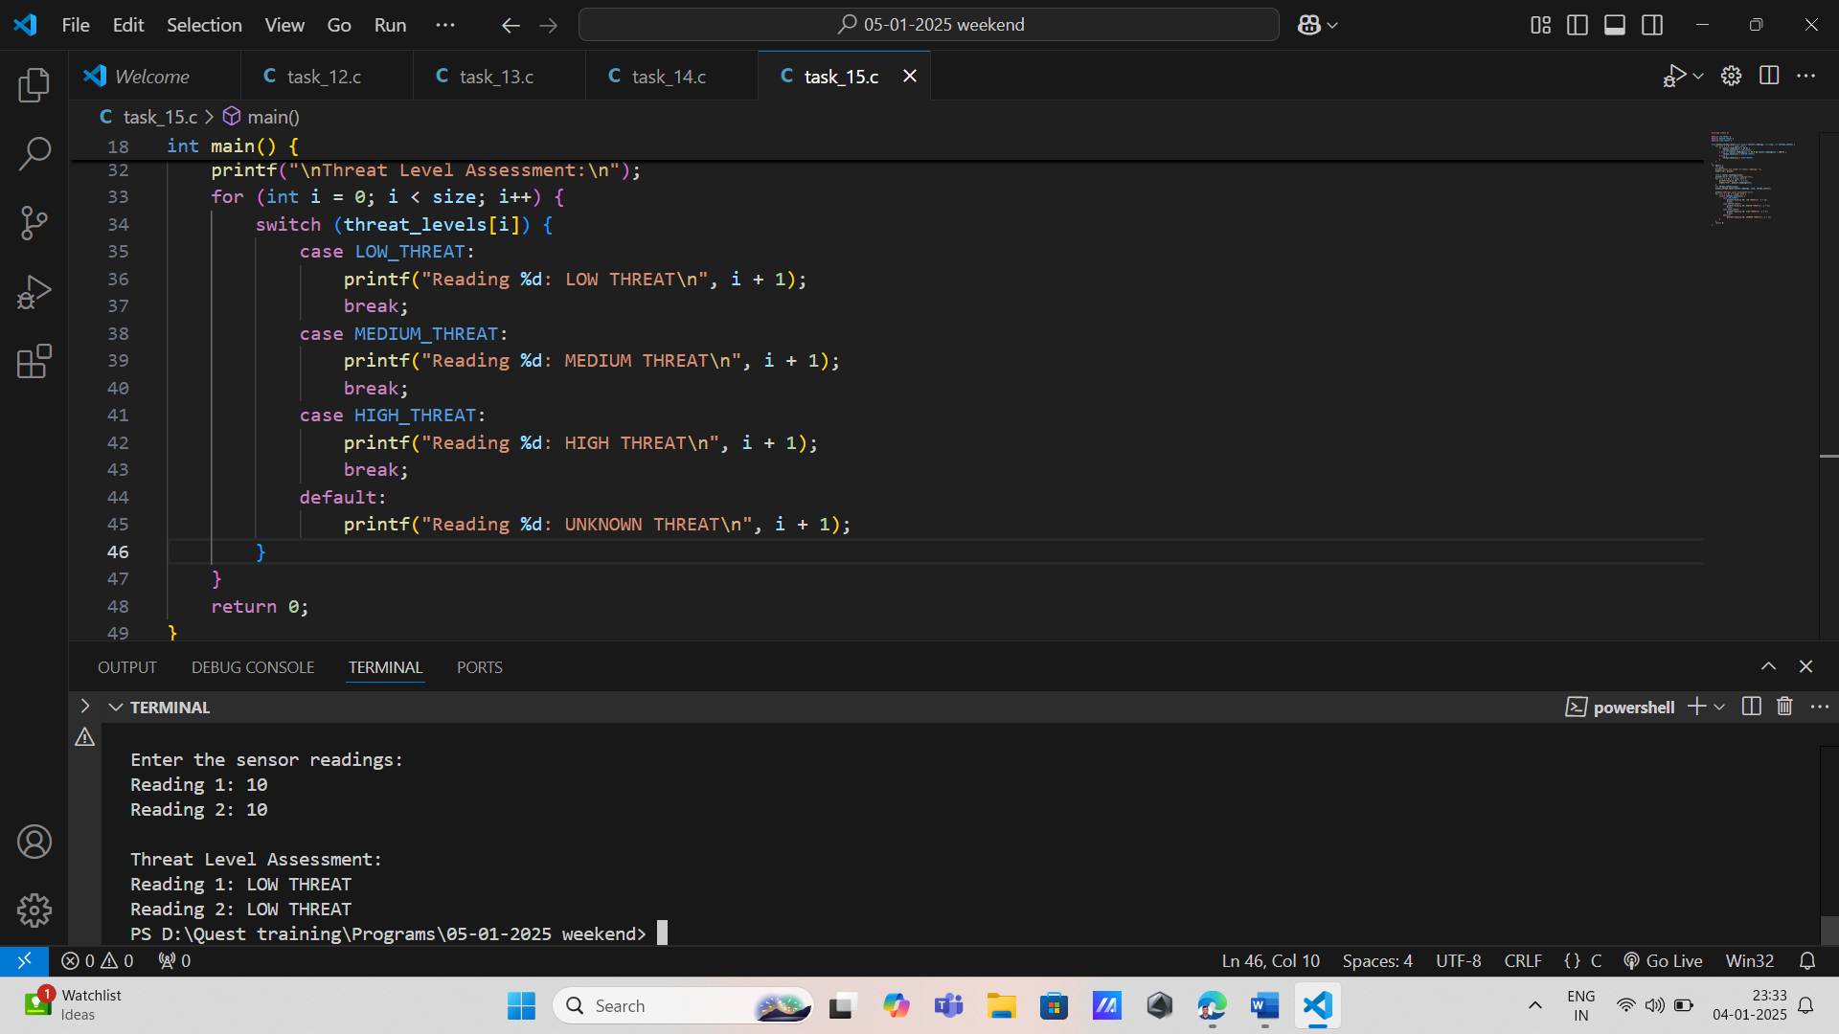

16. Signal Calibration

\* Input: Array of raw signal data.

\* Process: Use a function to adjust signal values by reference. Use pointers for data traversal.

\* Output: Print calibrated signal values.

\* Concepts: Arrays, pointers, functions, loops.

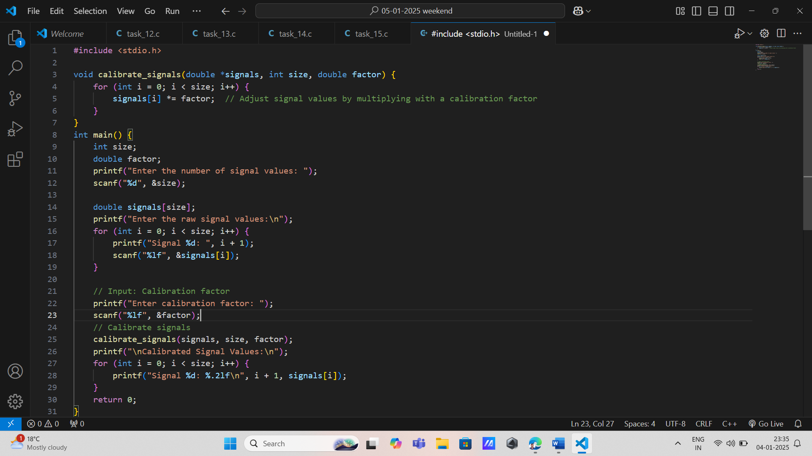

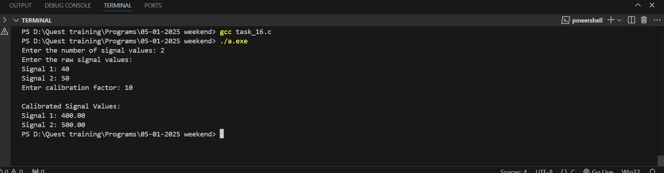

17. \* Matrix Row Sum

\* Input: 2D array representing a matrix.

\* Process: Write a function that calculates the sum of each row. The function returns a pointer to an array of row sums.

\* Output: Display the row sums.

\* Concepts: Arrays, functions returning pointers, loops.

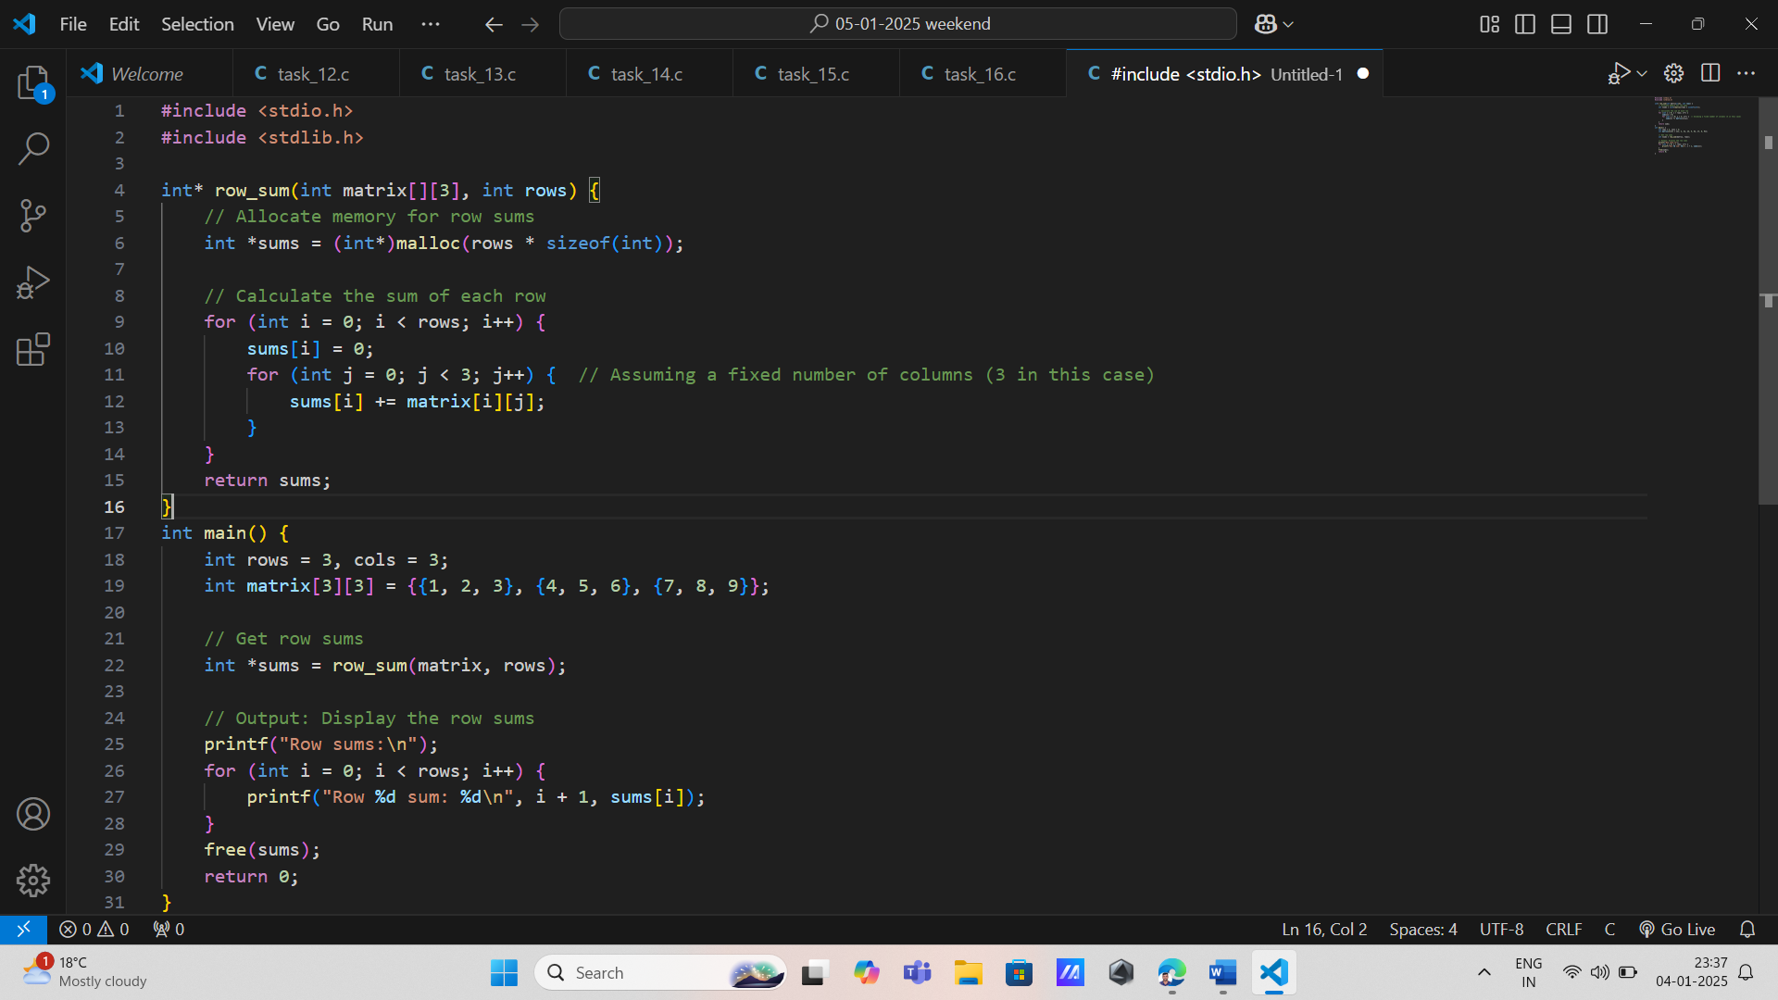

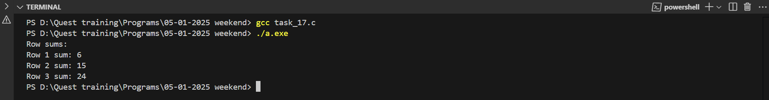

18. \* Statistical Mean Calculator

\* Input: Array of data points.

\* Process: Pass the data array as a constant parameter. Use pointers to calculate the mean.

\* Output: Print the mean value.

\* Concepts: Passing constant data, pointers, functions.

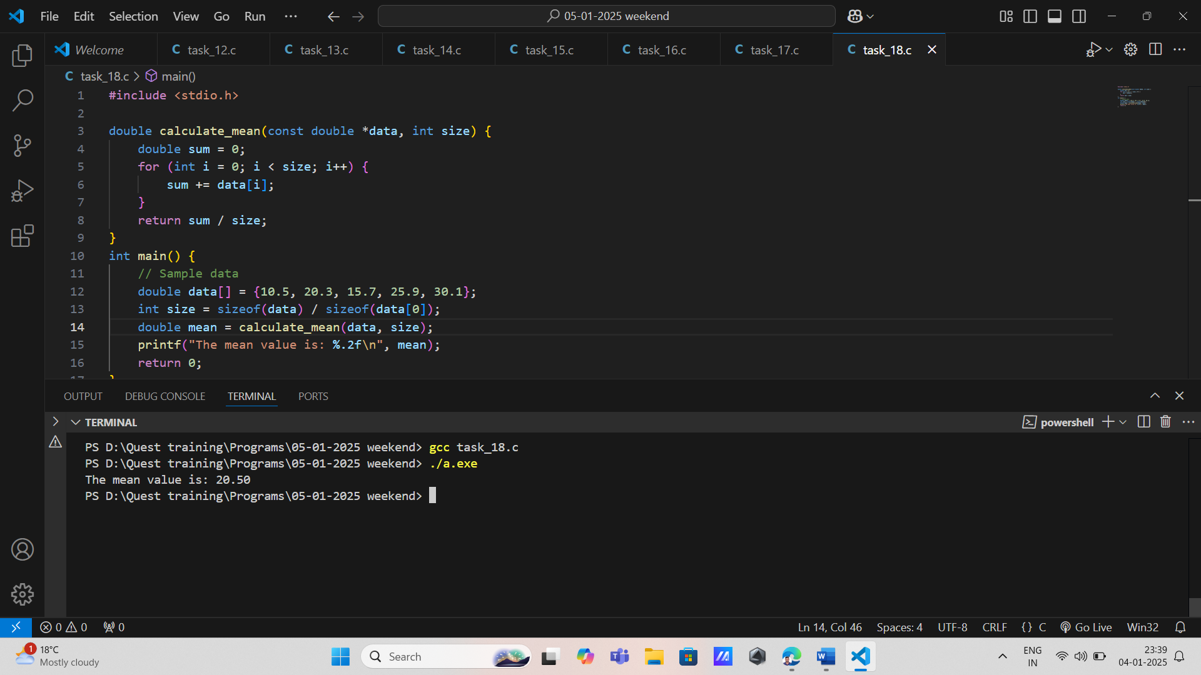

19. \* Temperature Gradient Analysis

\* Input: Array of temperature readings.

\* Process: Compute the gradient using a function that returns a pointer to the array of gradients.

\* Output: Display temperature gradients.

\* Concepts: Arrays, functions returning pointers, loops.

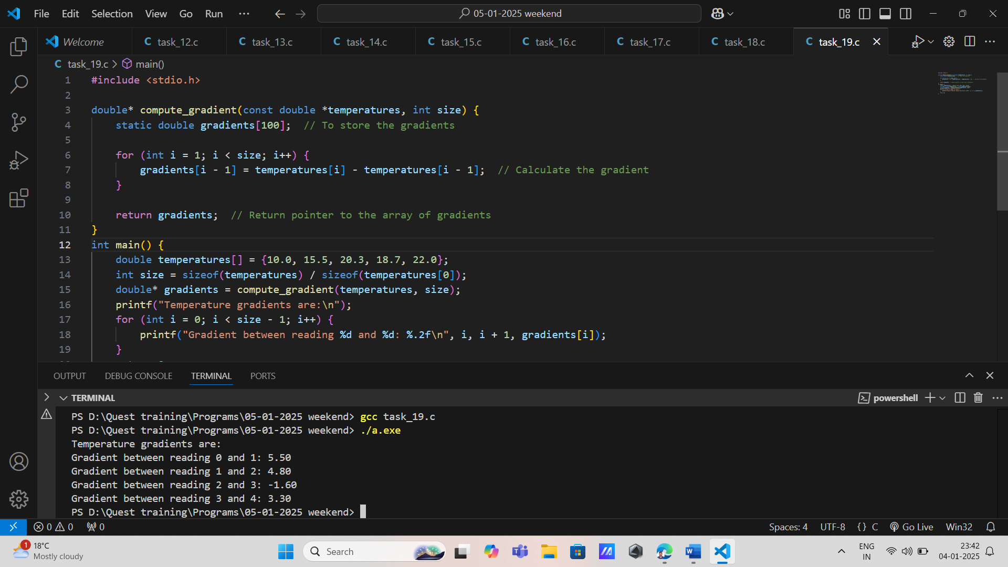

\*20. Data Normalization \* Input: Array of data points.

\* Process: Pass the array by reference to a function that normalizes values to a range of 0–1 using pointers.

\* Output: Display normalized values.

\* Concepts: Arrays, pointers, pass by reference, functions.

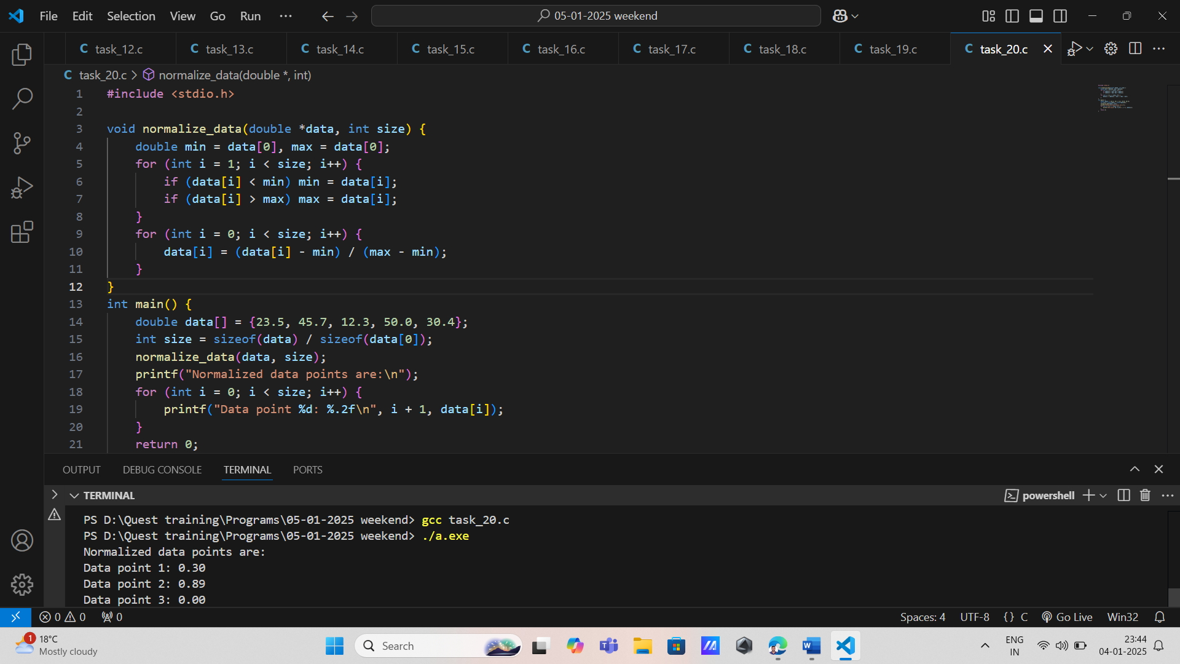

21. Exam Score Analysis

\* Input: Array of student scores.

\* Process: Write a function that returns a pointer to the highest score. Use loops to calculate the average score.

\* Output: Display the highest and average scores.

\* Concepts: Arrays, functions returning pointers, loops.

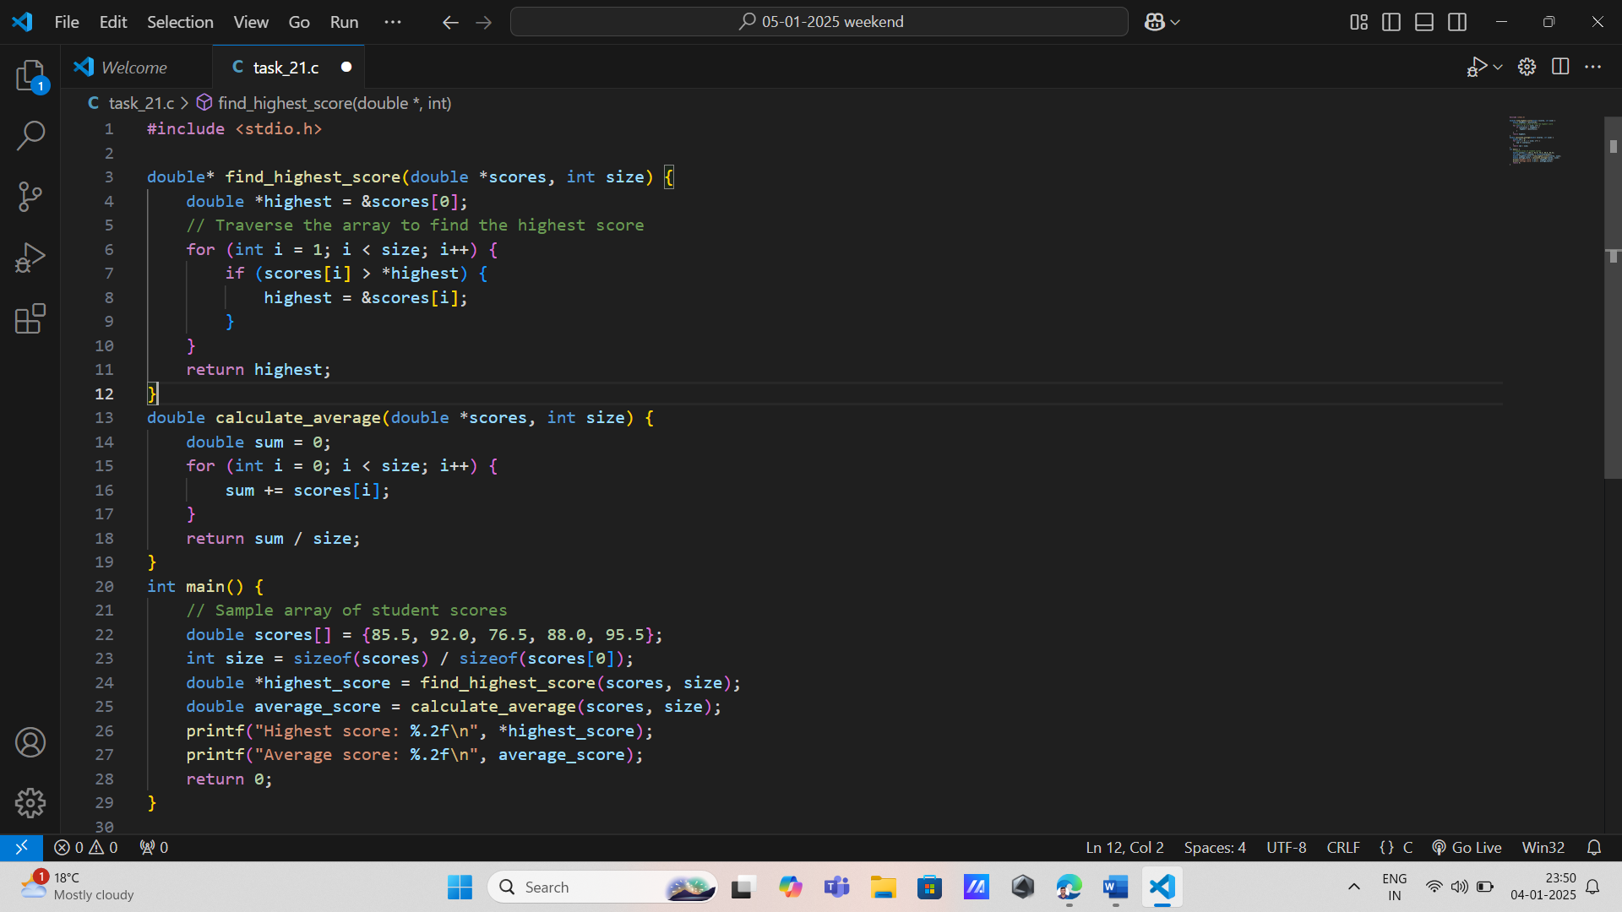

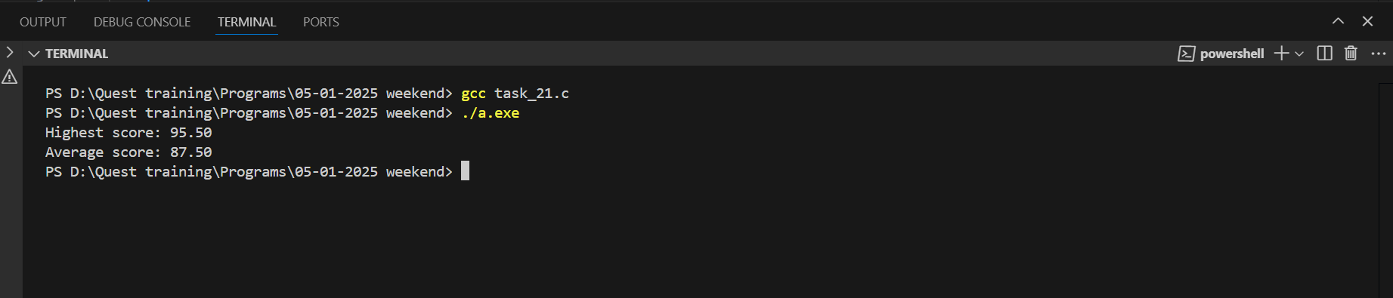

22. Grade Assignment

\* Input: Array of student marks.

\* Process: Pass the marks array by reference to a function. Use a switch statement to assign grades.

\* Output: Display grades for each student.

\* Concepts: Arrays, decision-making, pass by reference, functions.

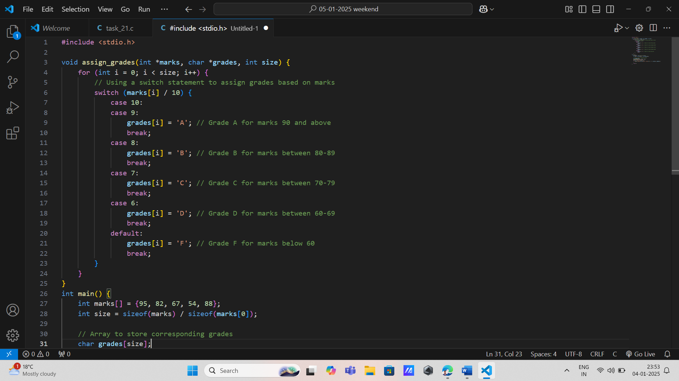

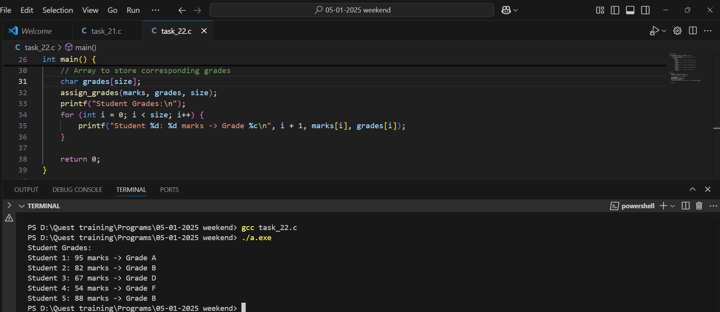

23. Student Attendance Tracker

\* Input: Array of attendance percentages.

\* Process: Use pointers to traverse the array. Return a pointer to an array of defaulters.

\* Output: Display defaulters’ indices.

\* Concepts: Arrays, pointers, functions returning pointers.

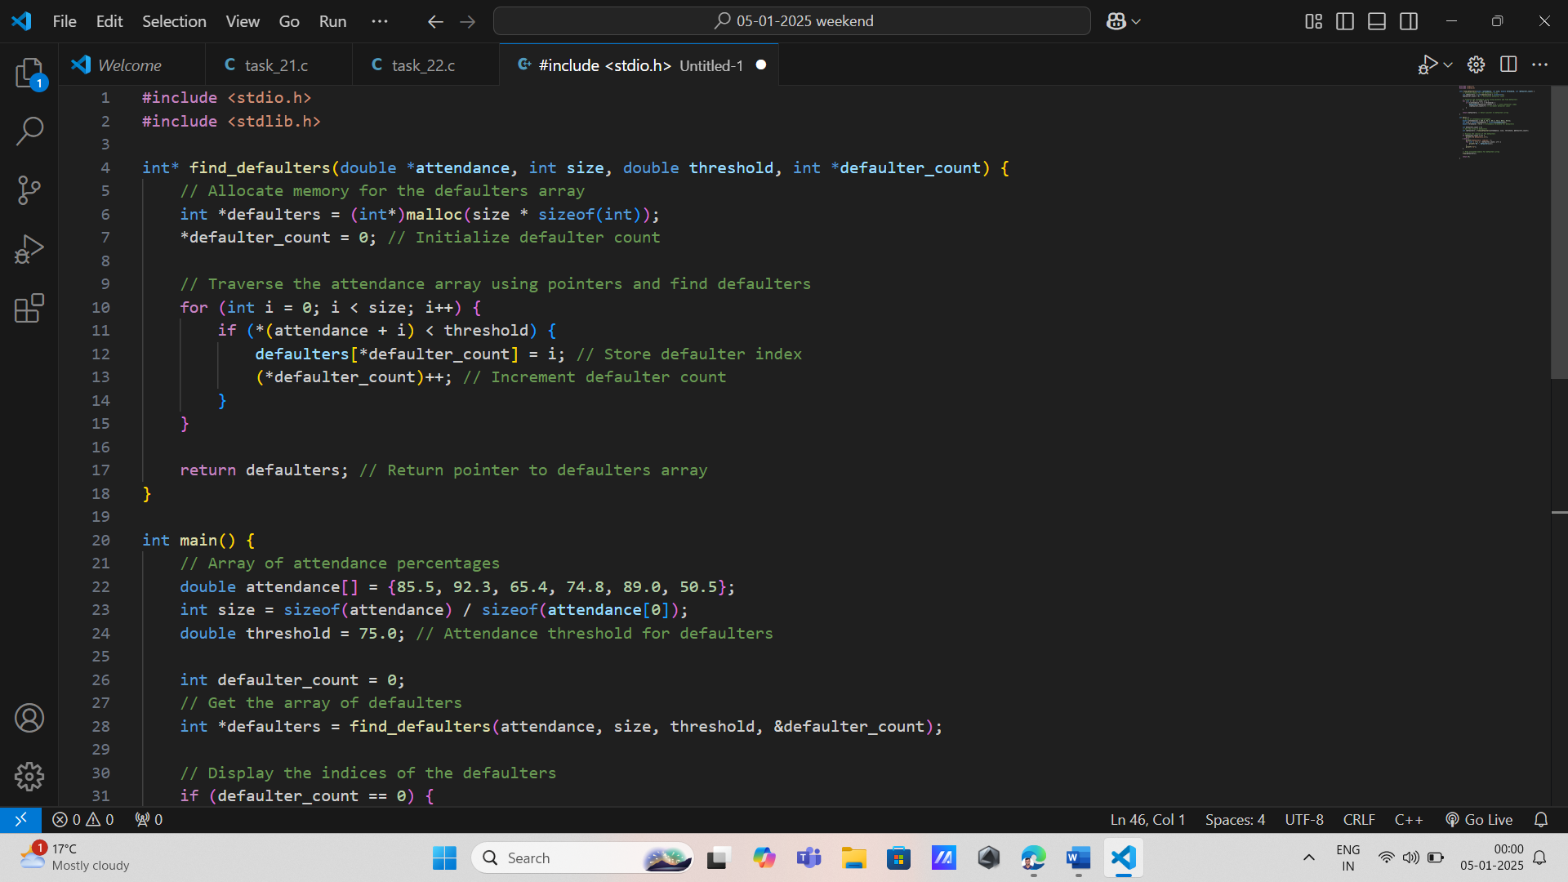

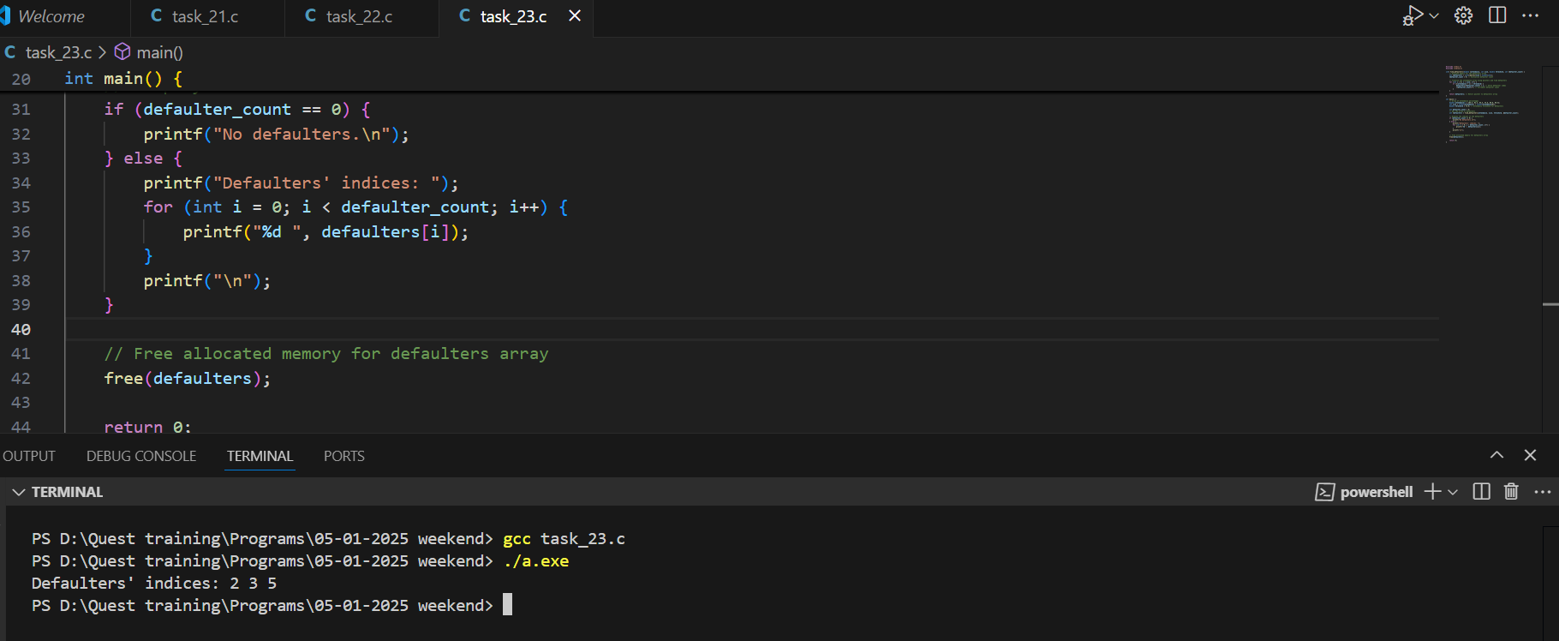

24. Quiz Performance Analyzer

\* Input: Array of quiz scores.

\* Process: Pass the array as a constant parameter to a function that uses if-else for performance categorization.

\* Output: Print categorized performance.

\* Concepts: Arrays, passing constant data, functions, decision-making.

